Smash Bros. Inspired Fighting Game in Unity



Key Game Features
- Title Screen
  - Title of game
  - Start Button
- Main Level
- Rematch Button
- Quit Button

Game Details
- 2D Fighting Game
  - Made in 3D, due to the use of 3D models and renders
- Multiplayer Game (2 players bare minimum)
  - Can also be played by one player, of course
    - Battles against an AI
- Special Effects
- Multiple Attacks (will be physical)
  - Kicks
  - Punches
- Jumping
- Getting hurt by attacks
  - Includes knockback, after taking lots of damage
  - Receive damage in the form of percent
    - Will make it be a stamina match for simplicity sake

The Player
* The player model for the 2 players I made uses my low-poly model, and it will utilize moves that are reminiscent to fighters like the Mii Brawler and Mario, as examples (long stories in themselves)
- Attack 1: Punch
  - The most basic attack; jabs opponent
- Attack 2: Kick
  - Stronger than the punch

Stage
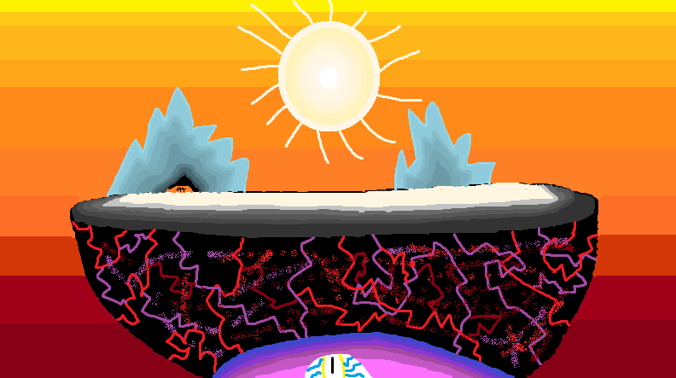
Picture made through the Microsoft Paint App (can’t use this in Unity, however, but the idea is that this game is supposed to revolve around an apocalyptic-like scenario)

Start Screen
Click to Start
End of Match Screen
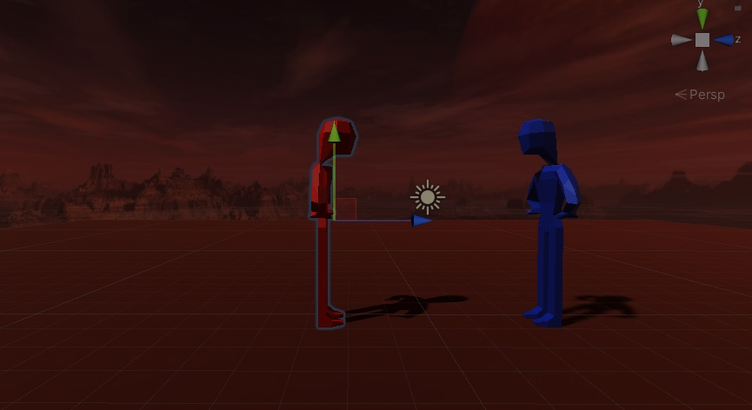
Retry
Quit

