Saido’s Quest: Design Document
Lane Ackerman

Overview

- overview for publishers
- Gameplay (This is the huge part - what is your game, how is it played)
  - Screen flow
  - game logic
  - interface
  - controls
  - and a lot more
- Characters (PCs, NPCs, behaviors, motivations)
- Story - synopsis, narrative flow, major points
- Game World (what is needed in the environment, how the world works)

Publisher overview.
Saido’s Quest is a 2-dimensional metroid-vania adventure role-playing game. The game is set in a version of feudal era Japan and centers around a pair of rival samurai. The core loop of the game revolves around clearing waves of enemies as you progress through sub levels within a level. You will traverse in a side scrolling platformer fashion and you will kill enemies by using a combination of your basic attack combos and your Oni techniques. As you complete a level there will be a menu where skill points can be allotted for upgrades in the Oni technique skill tree and weapons can be upgraded. One of the main ideological points of the narrative is to show the player walking the line between defeating monsters and becoming a monster, as well as showing that just because something is typically viewed as evil does not mean that it is evil.
Gameplay
Screen flow
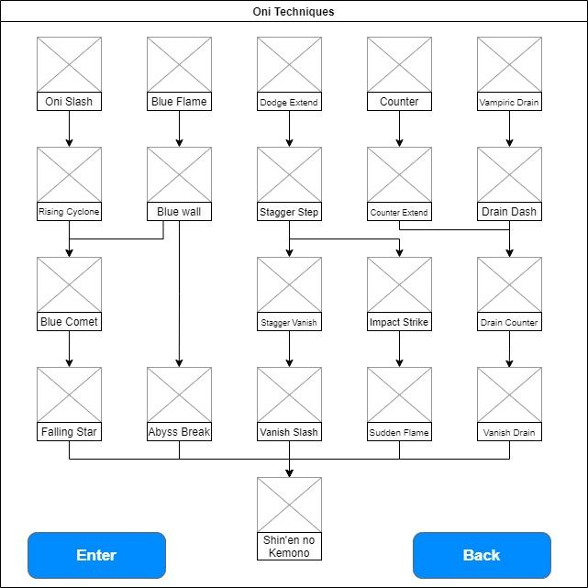
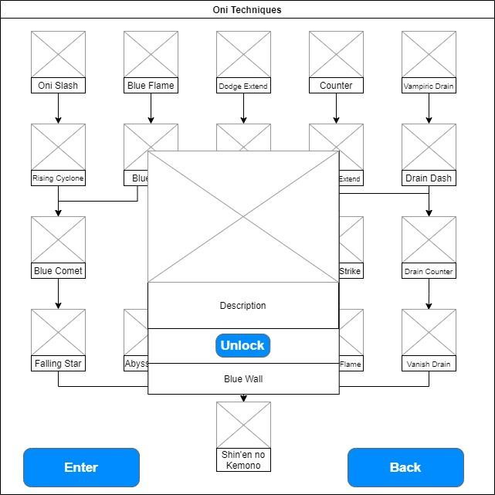
This is an example of the screen flow for unlocking new upgrades in the Oni techniques skill tree. Points will be unlocked over time based on enemies killed in levels on an experience point and level basis. You have the option tree with the skill names listed and an image depicting what the skill is. Selecting the skill and then pressing the input will bring up a submenu that has the skill name, a larger image, a description of the skill, and an unlock button.

Game Logic
At its core, the gameplay of Saido’s Quest revolves around maneuvering across sections of platforms and completing various actions while simultaneously defeating enemies. These actions can be quite varied, ranging from looking for a specific item drop to open the pathway to the next section or completing a puzzle or perhaps even learning how to deal with a new type of enemy with it’s own playstyle. There will also be challenging bosses which are designed to truly test the players ability to put the new mechanics they learned earlier in the level to the test and make them “think on their feet”. I want the game to really test the players' tactical thinking in ways not many platforming games focus on.
Interface

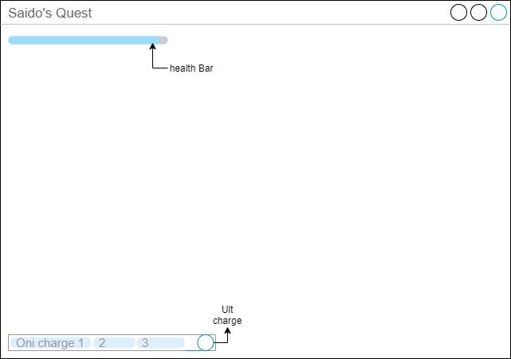

This is a mockup of the user interface for the main HUD of the game. I chose to keep the interface elements of the HUD minimal to avoid detracting from the gameplay elements on the screen. So, the only elements on the HUD are the health bar in the top left corner and the Oni charge and Ult, or ultimate, charge meter in the bottom left corner. As explained in the next subsection, Saido’s ability to perform Oni techniques hinges upon his Oni charge. Oni charge is increased by landing attacks on enemies, doing so also increases the ultimate charge gauge by a slight amount. Health can be regenerated by picking up crimson stones that drop from enemies.

Controls
Saido's Quest control table (xbox controller base)
Move left | thumbstick left
Move right | thumbstick right
Jump | A
Melee attack | X
Oni technique | B+thumbstick
Guard | Y
Grab | Y+X
Drain | Y+B
Vanish | Y+A
True Oni Technique | RT + thumbstick
Ultimate Technique | RT + B
Pause Menu | START

This is the base controller bindings for Saido’s Quest. Certain controls will not be available from the start, like Drain, Vanish, True Oni Technique, and Ultimate technique. Certain controls require proper timing to use successfully, like Vanish and using Drain after Vanish at later levels and using Guard at just the right moment to perform a counter. For the Oni Technique and True Oni Technique controls the move performed is determined by which direction is inputted along with the B button.

Levels
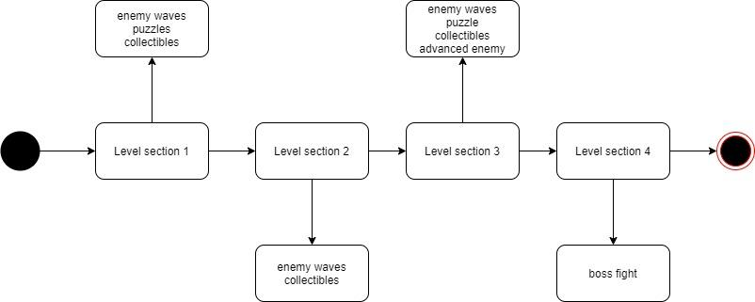

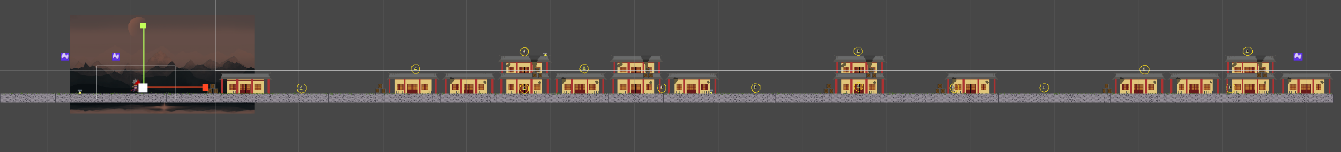

This is the basic layout of a level in Saido’s quest. Every level will be built using this basic format with the lengths of each section varying. The level will always start with a small cutscene before section 1. This will be followed up with the words begin flashing upon the screen to signal the player that they can begin the level. Players will then have to fight through various groups of enemies while simultaneously searching for collectibles and solving puzzles. The players will continue this with each section and section 3 will have an additional group of more challenging enemies. These enemies will be designed to teach the player the core mechanic around which the boss fight revolves. The next section is the boss fight where the players will be forced to put what they’ve learned from the previous section to the test and under high pressure. That is the core breakdown of the levels in the game.

Characters

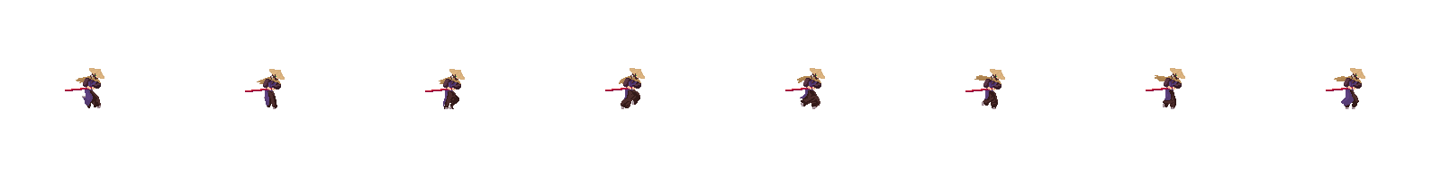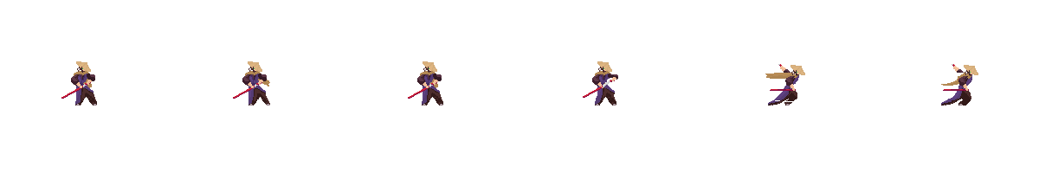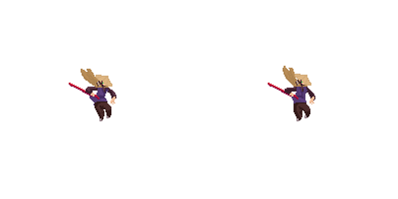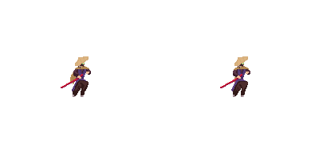
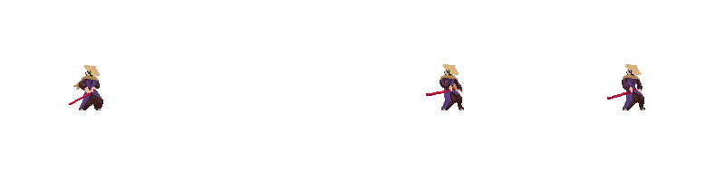

Jyuroni Saido
Member of a samurai clan who came home to find the clan decimated and overrun with yokai. He discovers his lifelong rival Tsukichi Kotaro bonded with a red Oni and led the yokai attack on the Shoin-Zukuri. He bonds with a blue Oni to hunt down Kotaro and his red Oni. He tries to maintain an appearance of detachment but cannot help but go to innocents in need, but he is not naïve and is willing to do what must be done. He views the world as a mix of grey and prefers to believe in a sense of honor and less of right and wrong.
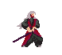

Tsukichi Kotaro
A former member of a samurai clan who became corrupted due to trauma. He ends up bonding with a powerful red Oni and leads an army of yokai to attack the home of his former clan. He possesses an incredibly powerful sense of justice and has always seen the world as black and white. He was corrupted when he saw a group of soldiers relentlessly beating a mother and her child that could not pay their taxes and ended up killing them. This violated his sense of justice and caused him to see humanity as full of evil. This new outlook drives Kotaro to lead the yokai attack and kill Saido’s lover. The players learn of his true motivation towards the end of the game.

Mobs

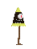
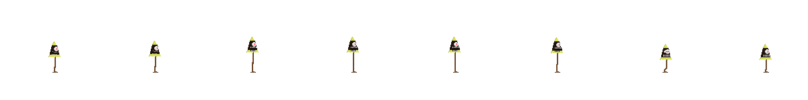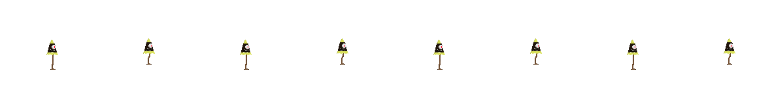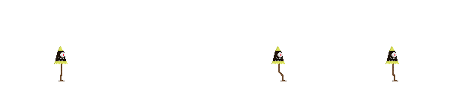

Obake
A lesser yokai that disguises itself as a parasol. These are lesser yokai and are therefore among the weakest enemies that Saido will face on his journey for vengeance. But one should not be fooled by there small size and weak form, A swarm of them can overwhelm even the mightiest of warriors.

Story
The story focuses on two members of the same samurai clan, Jyuroni Saido and his rival Tsukichi Kotaro. The game opens with Saido returning to the clan home, or Shoin-Zukuri, to find it festering with yokai. As he fights his way further and further into the house, he finds Kotaro at the center. Saido arrives just in time to find Kotaro standing over the body of his lover. As Kotaro turns, they begin to battle and Saido quickly discovers that Kotaro bonded with a powerful red Oni and is now far too strong for Saido to defeat. Kotaro gravely wounds Saido and leaves him for dead. Saido is saved when a blue Oni who is trying to stop the Oni bonded to Kotaro offers to bond with him so they may work together to defeat Kotaro. Saido begrudgingly accepts to get his vengeance. The story continues with Saido traveling across Japan freeing villages and cities trying to hunt down Kotaro with each yokai leader slain bringing him closer to finding his nemesis. Saido also manages to tap into and master the powers bestowed upon him through his bond with the blue Oni, called Oni techniques. By the end Saido manages to find and defeat Kotaro finally achieving his vengeance and the game ends with him venturing off to live as a wandering swordsman with the Oni returning to the underworld.

Game World
The world of Saido’s quest is set in feudal era Japan. The game opens with a yokai attack on the house of Saido’s clan. This then leads to the entire country being mostly overrun with yokai and it is up to Saido to clear them out and purify the country while he seeks his vengeance upon Kotaro. But as the player progresses through the story, they begin to question if Kotaro is truly villainous as they learn more of his past and begin to understand his motivations. The game will show travel across Japan through the short cutscenes at the beginning of each level and each village and city being their own separate levels will give the opportunity to make them feel unique while maintaining the core metroid-vania platformer style. Certain levels will take place during the day and some will take place during the night according to the narrative. Like many other games of this genre, levels will incorporate destructible objects that serve as both temporary obstacles and ways for the player to obtain items such as crimson stones, Oni energy, and mission items such as a key to open a gate stopping the player from progressing. As a platformer it only makes sense that physics will play a large role in how the game plays. Players will need to use the platforms to reach elevated areas and aerial enemies as well as dodging attacks from enemies and environmental hazards. The backgrounds in each area will give players a sense of the damage that has been inflicted by the yokai assault on each town and city as well as displaying the differences in quality

