Garph game design document

References: Corridor, chinese checkers

Number of players: 2

Why this game should exist: not many abstract strategy games are being made nowadays. Plus it is not really like other games.

Why it is fun: It is satisfying to outsmart your opponent, or for them to outsmart you just for you to outsmart them back.

Platform(s): Physical board game, pc port coming later.

Target Audience: ages 12 and up.

Social media links:
https://www.instagram.com/the_game_of_garph/
https://twitter.com/SpiritShadow9

Average play time: 15 - 30 min

Core mechanics:
- Blocking your opponents
- Moving your piece
- Jumping your own walls

Words that describe the game: Brain, minimalist, strategy, two, frustrating, physical, turns, serious, triangles, walls, abstract, variations, solvable, Garph, board, PVP, game, nonsense, crossing, opponents.

How to play Garph

Objective: Get to the other side.

What’s included: Game board, two player pieces, 10 beige Garph pieces, 10 purple Garph pieces, 4 black blockers.

Set up: Both players take one player piece and ten Garph pieces corresponding to their color. Each player places their player piece in the starting circles. Draw lots to decide who goes first.
Play: Players take turns. During their turn they can either move one space along a line or place two Garph pieces. Both players must always have a way to the other side of the board.
Moving: Players move along the lines. They may move forward, backward, or side to side. Once a player’s hand has left their player piece they may not move it again until their next turn. A player may not move into a space occupied by a Garph or another player. They may, if possible, jump their own color Garph. Players may jump one another. A player must make a move if posible. If no move is posible the player may forefight their move. Players may not occupy the same space.
Placing a Garph: If you place one Garph you must place a second one. Once the players had has left the Garph it cannot be moved. When placing a Garph you must place it where two or more triangles meet. You do not have to place your second Garph next to your first. You may not place a Garph in a space occupied by either player or another Garph.
Jumping: When jumping, you must jump in a straight line. You may only jump a Garph or a player if you are directly in front of them. To complete a jump place your player piece in the space directly behind the object you jumped. You may not land on your own or the opposing players Garph when completing a jump. Jumping a Garph or player counts as your turn. You may not jump directly after moving. You may only jump one Garph per turn. If a player is in front of a Garph of your color and you are in front of them you may jump both the Garph and the opponent piece, if it is in a straight line.
Variations:
NPC: Place the four blockers on the black spaces on the board. These pieces are special in that neither player can jump them. Once these pieces are played they cannot be moved. Garph pieces can not be placed on blockers.
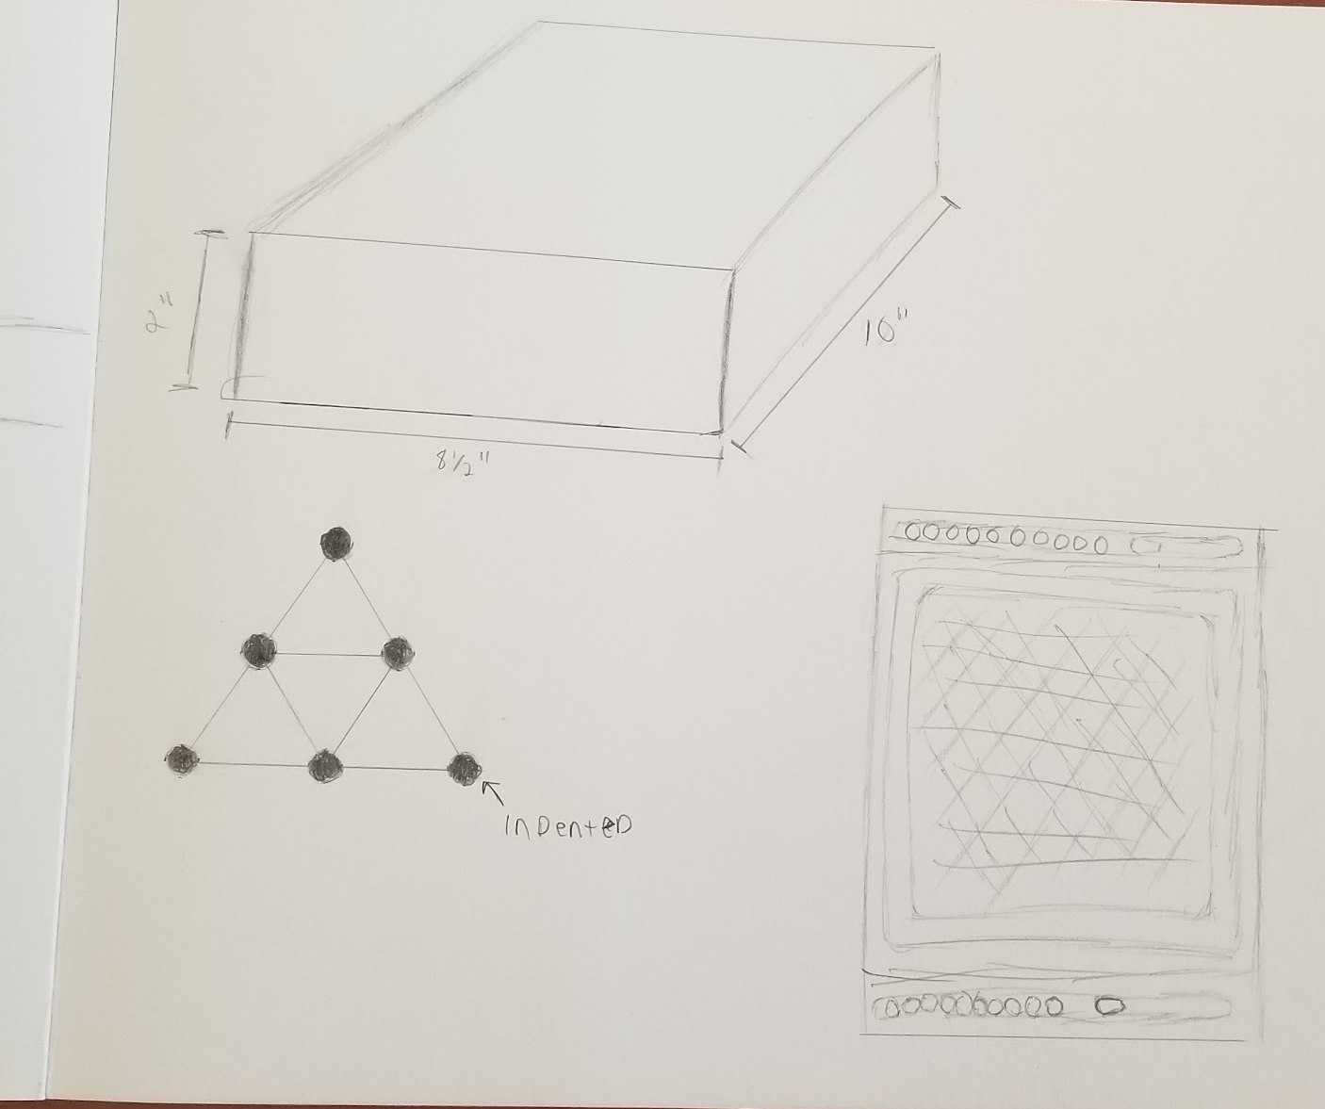
MORE WALLS!!!: Treat all Garph pieces as blockers. Players can not jump over their own color Garph pieces in addition to not being able to jump over the opponent's Garph pieces.

