Northern Winds – Design Document

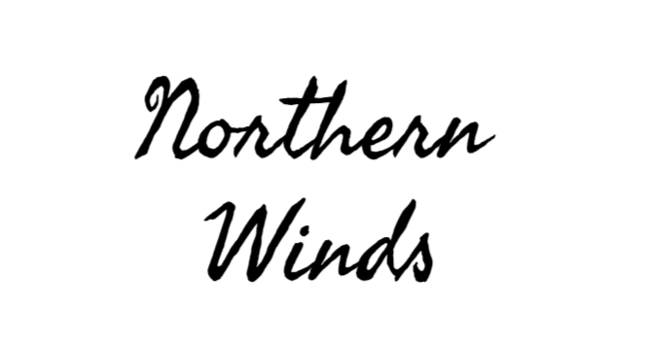

Gunnar Hunt
Table Of Contents
Key Features
- Inventory -
- World Interactivity -
- Location -
- Working Survival Statistics -
- Results -
Other important features
- Fishing/Hunting -
- Mining & Tree Chopping -
- Items & Functions of Items -
- Aesthetics -
Inventory

Max. Size (Number of Individual items): 15(Initially), 25(Bag Equipped)
Stacking Items: Aimed to be included, unless later stated not.
Non-Stackable Items: Yes.
Trashing System: Yes.
The inventory system is in the implementation phase, and it is planned that it has a somewhat clean UI and to have inventory icons for items, whether they be very basic or eventually improved. The icons are aimed to be basic, but recognizable. The icons will be help in small boxes, which will have a render or image of the item you have. There will be a small Trash Can Icon in the corner to signify, and the button to trash will likely be ‘r’
If items are stackable, the limit for each stack will be 5. (5 Wood, 5 Gold, 5 Copper, etc.)

World Interactivity

The world in this game is meant to be very interactable, with most objects, like Trees, Boulders, Animals, Lakes, Rivers, Bridges, and the Environment. You can break and destroy Boulders and Trees for materials, you can use Rivers and Lakes for fishing, in which fish can depend on if it’s a river or a lake, Bridges will hopefully be able to be built by the player. The environment will be aimed to be very against you. For example, the environment will make you cold naturally, and the snowy wind will surround you closely and eventually kill you when you are out in the open. I’m also aiming for there to be a lot of sound ambience, the wind growing louder and quieter, fish flopping, and walking and fire.

Location

The environment is very spread out, with mountains, lakes, forests, and islands scattered throughout. There will be boulders in forests and trees on mountains, but they will be a lot fewer and far between in those areas. It is centered on an island, with water on all sides, with small beaches on each side, and some destroyed structures scattered on the island.

Working Survival Statistics
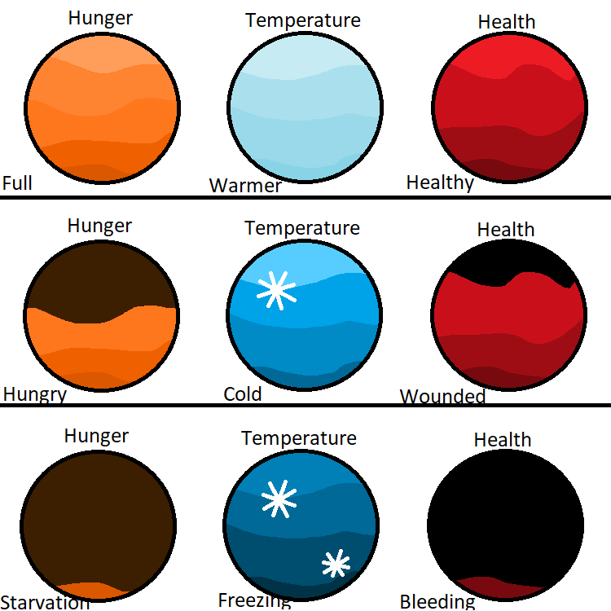
There will be Hunger, Temperature, and Health. Hunger goes down when you don’t eat and is replenished when you get food. Temperature will drop when away from fire, and will rise when near a fire, and/or under a sound structure. Health deducts rapidly when freezing, falling too far, and can only be gained in small quantities when eating food. Max Health: 100. Max Temp: 100, When Temp is 15, you start to freeze. Max Hunger is 150, drops 1 per 8 seconds.

Results
Achievements: 2000
Gold: 900
Copper: 300
Cinnabar: 500
Wood: 50
Sticks: 15
Fur: 275
Cutlet: 125
Meat: 250
Stone: 25
Ice: 10
Iron: 550
Fish: 200
Tin: 275
Bronze: 750
Bark: 5
Furniture crafted for house: Score 1.F x
(F is equal to the number of furniture crafted)
(E.g. If you made 3 items, score is 1.3x)

The Game can be ended once the player has established a home. Then they can then decide to end the game VIA pressing ‘0’. The score is calculated by adding the value of all the resources you have (Gold, wood, cinnabar, copper, etc.).
Fishing/Hunting

Groundhog HP: 10
(Aimed Inclusion) Deer HP: 20

Fishing is crucial to the game, as fishing is a really good way to get food. There is aimed to be 10 different types of fish, and one piece of fishing junk. Fish can also be used to make warming food and get more achievements to raise your score.
Hunting will be another important thing; it will be one of the only ways to get Fur. They also drop good meat, which will restore a lot of hunger.

Mining & Tree Chopping

Tree Chopping is very necessary to the game progression, as it is needed at nearly every step of making a house and making tools. You will start out with an axe and if it breaks, you can try to look for one in a ruined structure.
Mining is also very necessary, as mining is necessary to making nearly all furniture, tools, and steps for house building. They also heavily affect score depending on the ores you get.
Items & Functions of Items
Utility: These items are used to help the player or hinder the player with stat changes.
- Bag, increases inventory size
- Coat, decreases freeze rate
Tools: These have specific purposes and are meant to go and get other materials
- Ax, gets wood
- Pickax, get stones
- Rod, gets fish
Resources: These are gotten from chopping, mining, and killing/getting animals and other items.
- Woods, like Wood and sticks
- Stones, like gold, stone, and copper
- Animal Products, like fur
Food: These are gotten multiple ways, and are the best way to gain health and the only way to gain hunger.
- Berries, restore tiny amounts of hunger
- Cutlets, restore mediocre amounts of hunger
- Fish, restores a good amount of hunger
- Meat, restores a lot of hunger
- All their cooked variants

Aesthetics

Sound: Sound will be implemented into the game for atmospheric effects.
- Animal sounds, predominantly walking.
- Tree sounds, chopping and occasional leaves rustling.
- Ore sounds, like stone being mined.
- Wind sounds, for the wind that is constantly whirring around the player.

Vision: There will be a near constant wind sphere that will be around the player constantly, and the view range will grow when near light and under shelter. It grows closer and kills the player if left away from these.

Music: Music is something I hope to add, but I’m hoping for it to feel very ‘Wintery’ and lonely feeling.

