The Last Summer Vacation Game

Starting notes

Genre: horror/ adventure
Setting: 1980s horror movies, A worn down board walk town filed with mysterious happen stance.
Inspiration: fantasy high, stranger things, lost boys, Friday thirteenth, tma, Halloween, scream, monster of the week
Summary: The World focuses on the town of Cape Harpchester and the surrounding mountains and forest. This town was a popular tourist destination until a lot of violent murders, killing sprees, disappearances, and other mysterious happenings started to rock the town. It drove away tourists leaving the town rundown and the locals struggling. After many years the events subsided, tourists them flocked back to the town. The game takes place during the summer this swarm of tourists return.
Antagonists: The baddies will include slashers, creepy clowns, vampires where wolves, and other horror movie villains with one bbeg behind it all.
Themes:
Name of world: Cape Harpchester

Reference photos for setting:

Cape HarpChester
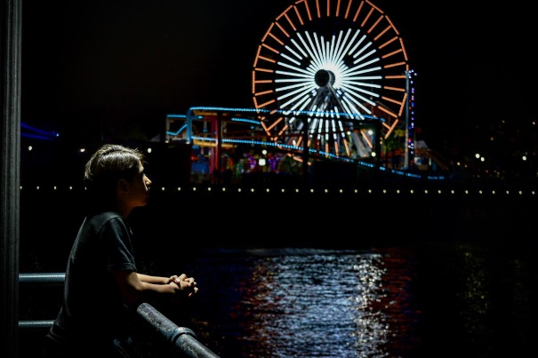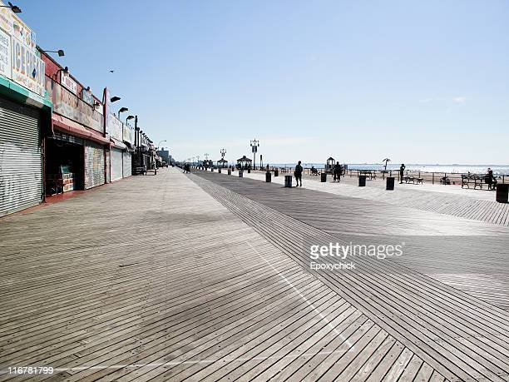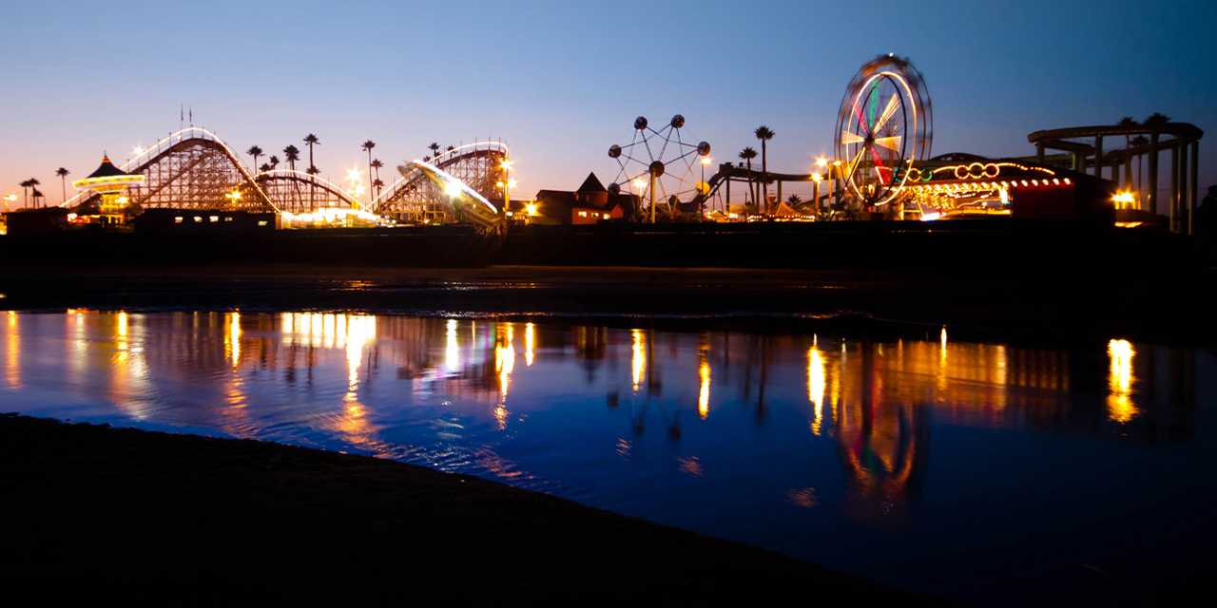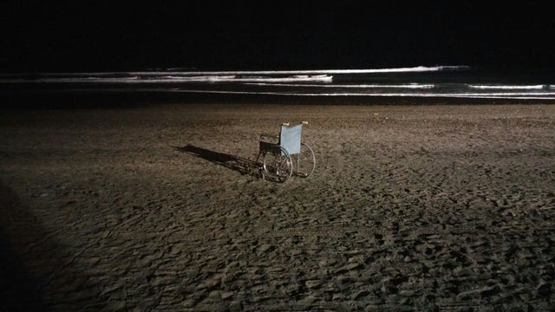

Stambury Grove
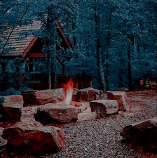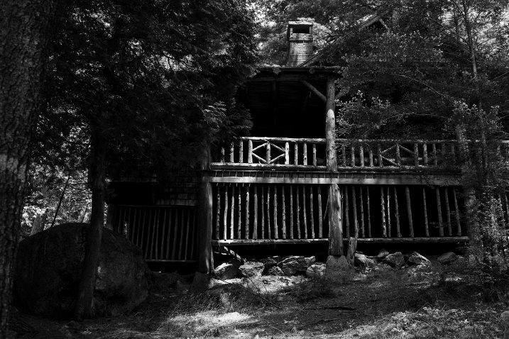

Underground
