Student Design Document 2023-2024

MD6111@questar.org - Graphics
Sample Screen(s):

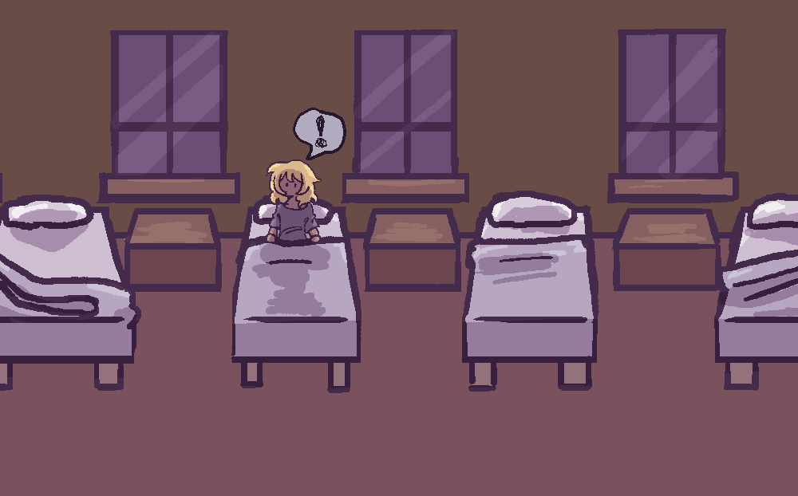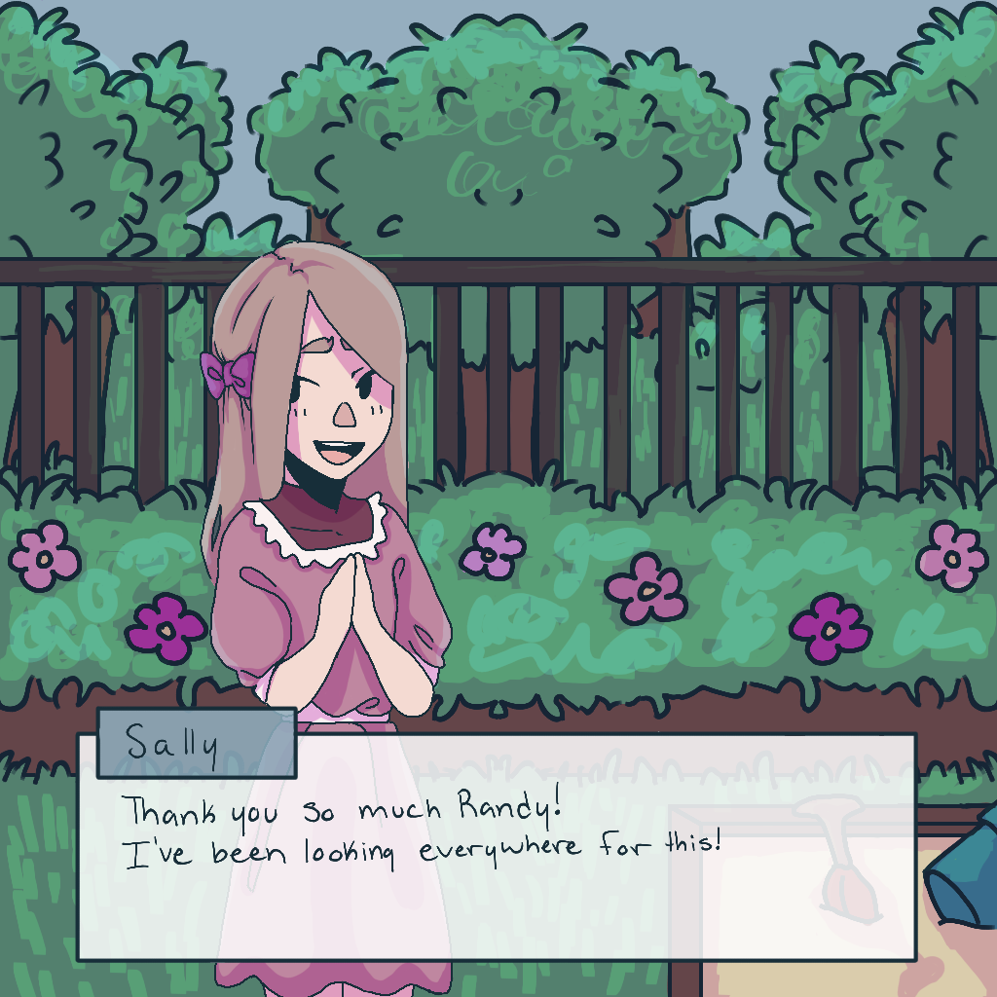

Violet Stitching

1. You play as a little girl who hallucinates, having to survive the nights at the orphanage from the terrible monsters that come from her hallucinations. During the day you must do various tasks for the other kids in the orphanage to get items to help you survive. But the more you progress the more aware the staff are of the little girl’s hallucinations, having to avoid them as well as the monsters.

2. A survive the night styled game with a day and night sequence.

3. Main Character Artwork:

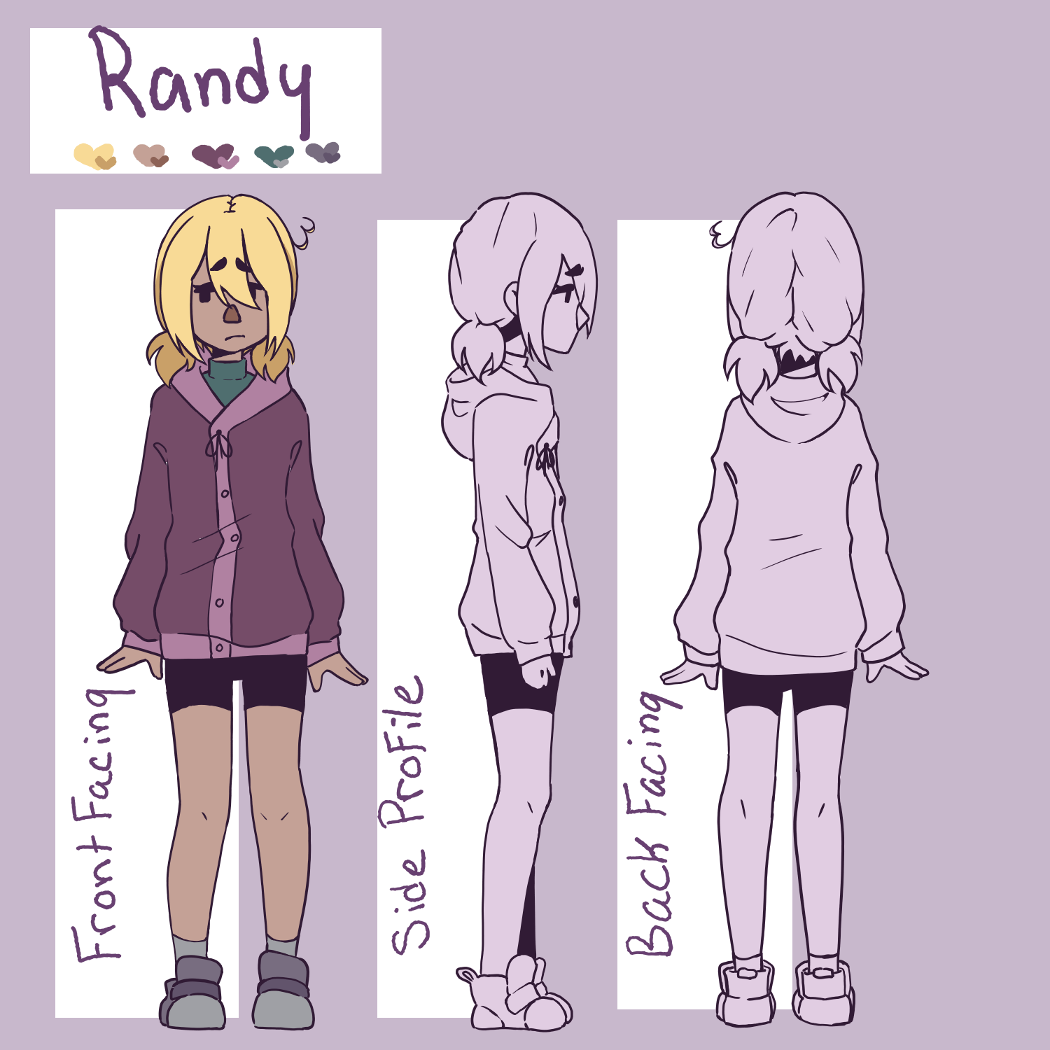

An 8 year old girl. She has short blonde hair in pigtails, black eyes, and peachy skin. She's fairly shy and often carries a cat plushie around. She wears a pink jacket, black shorts, a green turtle neck underneath the jacket, white socks, and purple shoes.

Obstacles:
The main obstacle the MC will encounter are monsters that chase her around and she has to escape them without dying.

Goal:
The goal in the game is to survive the nights and escape the orphanage.

Point of View:
3rd

Interface:
I don't know how to describe it

Controls:
WASD

PLACE IMAGE

User Emotions:
fear

Levels:
Different distorted rooms - of a house or backyard - and dream-like levels.

